Ideation Phase
Empathize & Discover
Date | 30 September 2026
Team ID | SWTID-2026-8273
Project Name | Implement Client Script & UI Policy (Incident)
Target User | Service Desk Agent / Incident Manager
Maximum Marks | 4 Marks

Empathy Map Canvas
An empathy map is a simple, easy-to-digest visual that captures knowledge about a user's behaviours and attitudes. It helps the team understand the Service Desk Agent who logs and resolves incidents in ServiceNow, so that the Client Script and UI Policy solution addresses their real problems.

Empathy Map
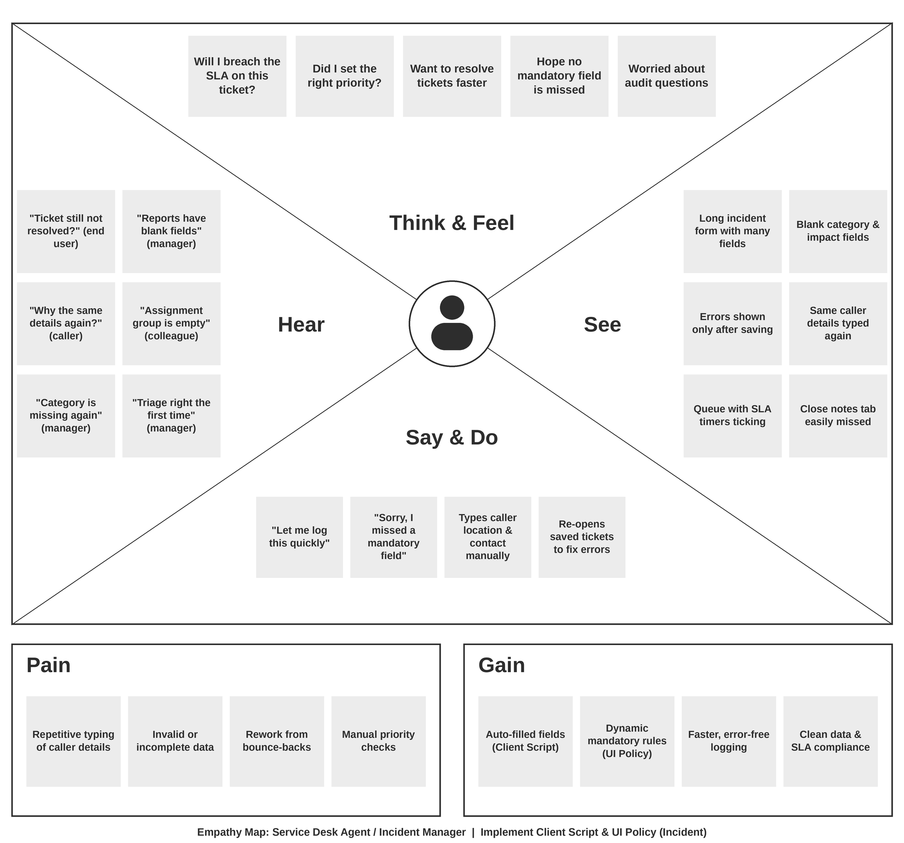

1. Basic Details
- Date: 30 September 2026
- Team ID: SWTID-2026-8273
- Project Name: Implement Client Script & UI Policy (Incident)
- Target User: Service Desk Agent / Incident Manager
- Persona summary: Logs incidents from calls, chats, emails and the portal; triages, assigns and resolves them within SLA targets on the ServiceNow platform.

THINK & FEEL
What keeps them up at night?
- Missing an SLA breach because an incident was logged with the wrong priority or category.
- Tickets bouncing back and forth between teams due to incomplete or vague descriptions.
- Closing an incident without resolution notes or close code and being questioned in an audit.
- Critical P1 incidents being mis-triaged while they are busy fixing data-entry mistakes.
Aspirations
- Log and resolve incidents faster, with fewer clicks and no manual errors.
- Trust that the form guides them, so mandatory data is always captured correctly.
- Spend time solving user problems rather than fixing ticket quality issues.
- Be recognised for high first-call resolution and consistent SLA compliance.

HEAR
End users say
- "Why is my ticket still not resolved? I raised it hours ago."
- "Why do you keep asking me the same details again?"
Managers say
- "Too many incidents are missing category, impact or urgency. It hurts our reports."
- "We are breaching SLAs. Tickets must be triaged correctly the first time."
Colleagues say
- "This ticket has no assignment group and no details. Please update it."
- "Which field is mandatory when the state is On Hold or Resolved?"

SEE
On the ServiceNow interface
- A long incident form with many fields, several of them irrelevant to the current task.
- Fields such as Caller, Category, Subcategory, Impact, Urgency and Priority that must be filled by hand.
- Mandatory field asterisks that appear inconsistently, or error messages only after saving.
- Resolve/Close tabs showing Close Code and Close Notes that are easy to overlook.
In the daily workflow
- A growing queue of open incidents with SLA timers counting down.
- Colleagues re-opening or reassigning tickets because of incomplete data.
- Dashboards and reports with blanks and inconsistent values.
- Callers waiting on the phone or chat while the agent types the same information repeatedly.

SAY & DO
What they say publicly
- "Let me quickly log this and get it assigned."
- "I need the caller's details and a clear short description to proceed."
- "Sorry, I will have to update the ticket. I missed a mandatory field."
What they do daily
- Search for the caller, then manually enter location, department and contact details.
- Set category, impact and urgency by judgement, then check the resulting priority.
- Copy and paste text from emails and chats into the description field.
- Re-open saved forms to fix errors, and follow up with colleagues on incomplete tickets.
- Rely on personal checklists or memory to know which fields are required at each state.

PAIN
Frustrations
- Errors only appear after Save/Submit, so work is repeated.
- Inconsistent data entry between agents causes unreliable reporting.
- Pressure to log tickets quickly conflicts with the need for accuracy.
Manual effort and repetitive tasks
- Re-typing caller details, location and contact information for every incident.
- Manually deciding and updating priority when impact or urgency changes.
- Checking by hand whether close notes and resolution details were provided.
Invalid data submissions
- Empty or vague short descriptions and missing categories.
- Incidents resolved or put on hold without required notes or reasons.
- Wrong or mismatched values, such as an incorrect subcategory for the category.

GAIN
Wants and needs
- A simple form that shows only the fields needed at each stage.
- Instant feedback on mistakes before the record is saved.
- Consistent, reliable data that needs no rework.
Benefits of auto-populating fields (Client Script)
- Caller's location, department and contact details are filled in automatically on selection.
- Default values are set on new incidents, saving time and reducing typing mistakes.
- Faster logging, shorter call handling time and better first-call resolution.
Benefits of dynamic UI Policy validations
- Fields become mandatory, read-only or visible depending on state, category or priority.
- Close Code and Close Notes are enforced when resolving; On Hold Reason is enforced when on hold.
- Fewer bounce-backs, better SLA compliance, cleaner reports and greater confidence for the agent.

